1 a. Using trigonometric substitution
Given that $\int{\frac{dx}{\sqrt{x^{2}+a^{2}}}}$
This integral function can be evaluated by using trigonometric substitution
$let x=atanθ$
$→tanθ=\frac{x}{a}$
$dx$=a$\sec^{2}θdθ$
Therefore, $\int{\frac{1}{\sqrt{a^{2}\tan^{2}θ+a^{2}}}}×a\sec^{2}θdθ$=$\int{\frac{a\sec^{2}θdθ}{√a^{2}(1+\tan^{2}θ)}}$
=$\frac{1}{a}×a\int{\frac{\sec^{2}θdθ}{1+\tan^{2}θ}}$=$\int{\frac{1}{1+\tan^{2}θ}}∙\sec^{2}θdθ$
Using the identity, $\sec^{2}θ-\tan^{2}θ=1$
$\sec^{2}θ=1+\tan^{2}θ$
Then, $\int{\frac{1}{\sec^{2}θ}}∙\sec^{2}θdθ$
$∴ \int{\frac{dx}{{\left(x^{2}+a^{2}\right)}^{\frac{1}{2}}}}=\int{\frac{1}{\sec^{2}θ}}∙\sec^{2}θd$
=$\int{secθdθ}$
$=ln\left|secθ+tanθ\right|+c$
$=ln\left|tanθ+\sqrt{1+\tan^{2}θ}\right|+c$
$=ln\left|\frac{x}{a }+\sqrt{1+\frac{x^{2}}{a^{2}}}+\right|+c$
$=ln\left|\frac{x}{a} +{\left(\frac{a^{2}+x^{2}}{a^{2}}\right)}^{\frac{1}{2}}\right|+c$
$=ln\left|\frac{x}{a}+\frac{{\left(x^{2}+a^{2}\right)}^{\frac{1}{2}}}{a}\right|+c$
$=ln\left|x+{\left(x^{2}+a^{2}\right)}^{\frac{1}{2}}\right|-lna+c$
$=ln\left|x+{\left(x^{2}+a^{2}\right)}^{\frac{1}{2}}\right|+c (-lna is a constant)$
$=\int{\frac{dx}{{√x}^{2}+a^{2}}}=ln\left|x+{\left(x^{2}+a^{2}\right)}^{\frac{1}{2}}\right|+c$

1b. Using hyperbolic substitution
Given that $\int{\frac{dx}{{\left(x^{2}+a^{2}\right)}^{\frac{1}{2}}}}$
$let x=asinht$
$sinht=\frac{x}{a}$
$dx=acosht∙dt, and t=\sinh^{-1}\left(\frac{x}{a}\right)$
Now $\int{\frac{1}{{\left(x^{2}+a^{2}\right)}^{\frac{1}{2}}}}∙dx$=$\int{\frac{1}{{\left[{\left(asinht\right)}^{2}+a^{2}\right]}^{\frac{1}{2}}}∙acoshtdt}$
=$\int{\frac{1}{{\left(a^{2}\sinh^{2}t+a^{2}\right)}^{\frac{1}{2}}}}∙acoshtdt$
$=\int{\frac{acoshtdt}{{\left[a^{2}\left(1+\sinh^{2}t\right)\right]}^{\frac{1}{2}}}}$
$=\frac{1}{a}∙a\int{\frac{coshtdt}{1+\sinh^{2}t}}$
Since, $\cosh^{2}t-\sinh^{2}t=1$
$\cosh^{2}t=1+\sinh^{2}t$
$cosht={\left(1+\sinh^{2}t\right)}^{\frac{1}{2}}$
$∴ \int{\frac{dx}{{\left(x^{2}{+a}^{2}\right)}^{\frac{1}{2}}}}=\int{\frac{1}{cosht}∙coshtdt}$
=$\int{1dt}$
$=t+c$
$\sinh^{-1}\left(\frac{x}{a}\right)+c$
2. Using integration by parts
Given that $\int{\ln\left(x^{2}-x+2\right)dx}$

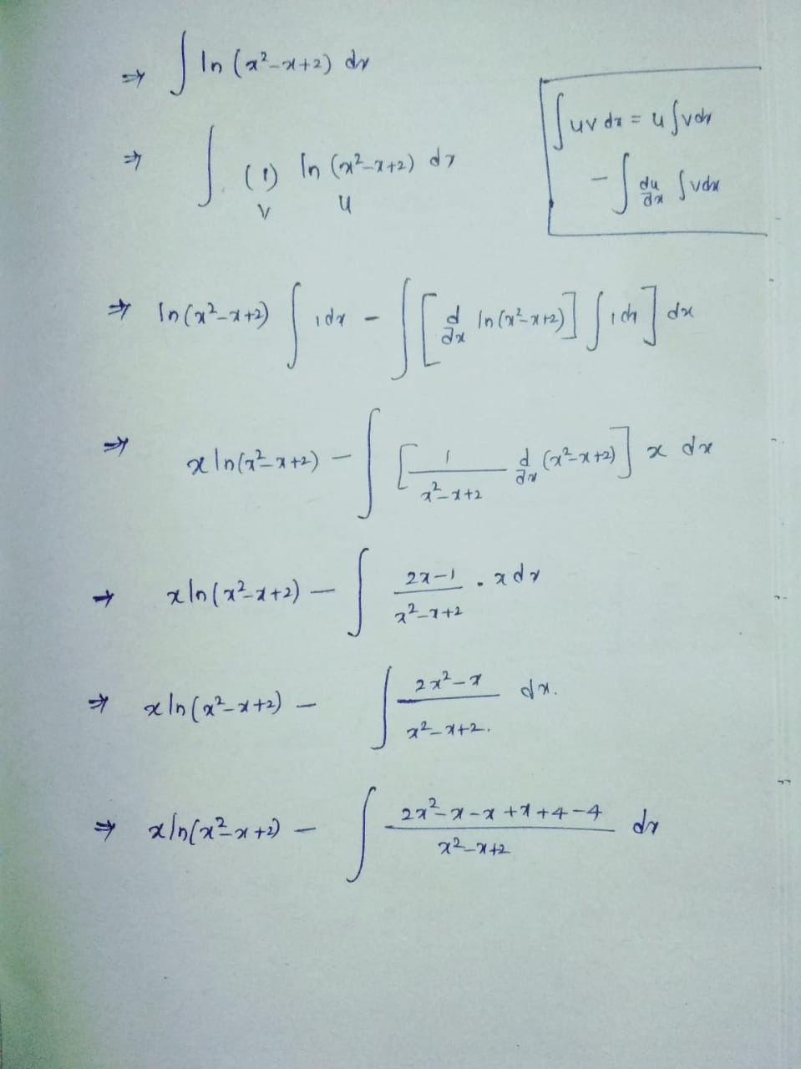

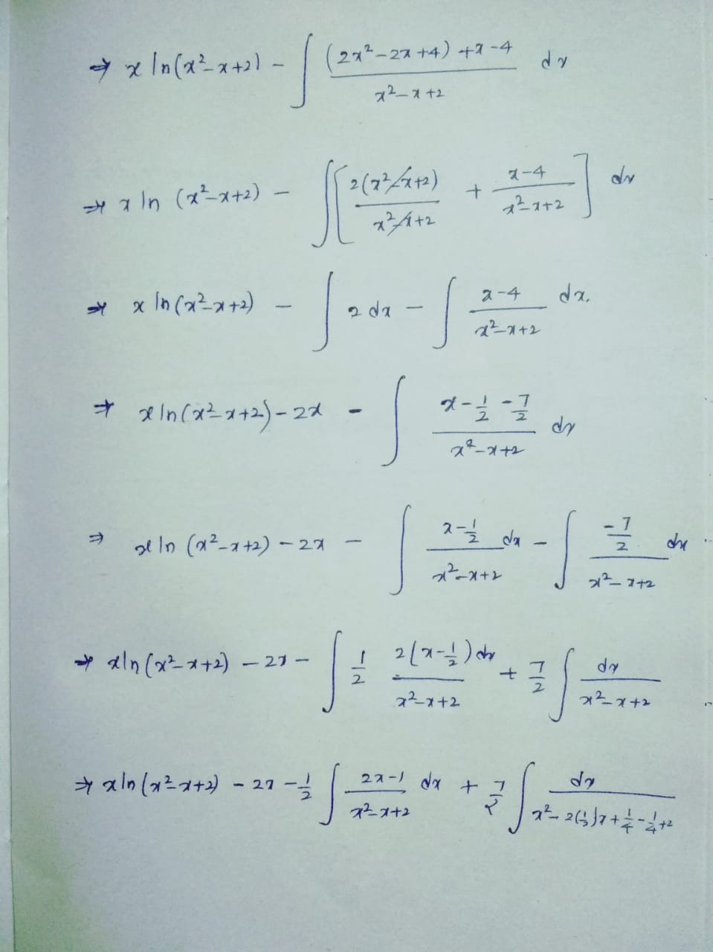

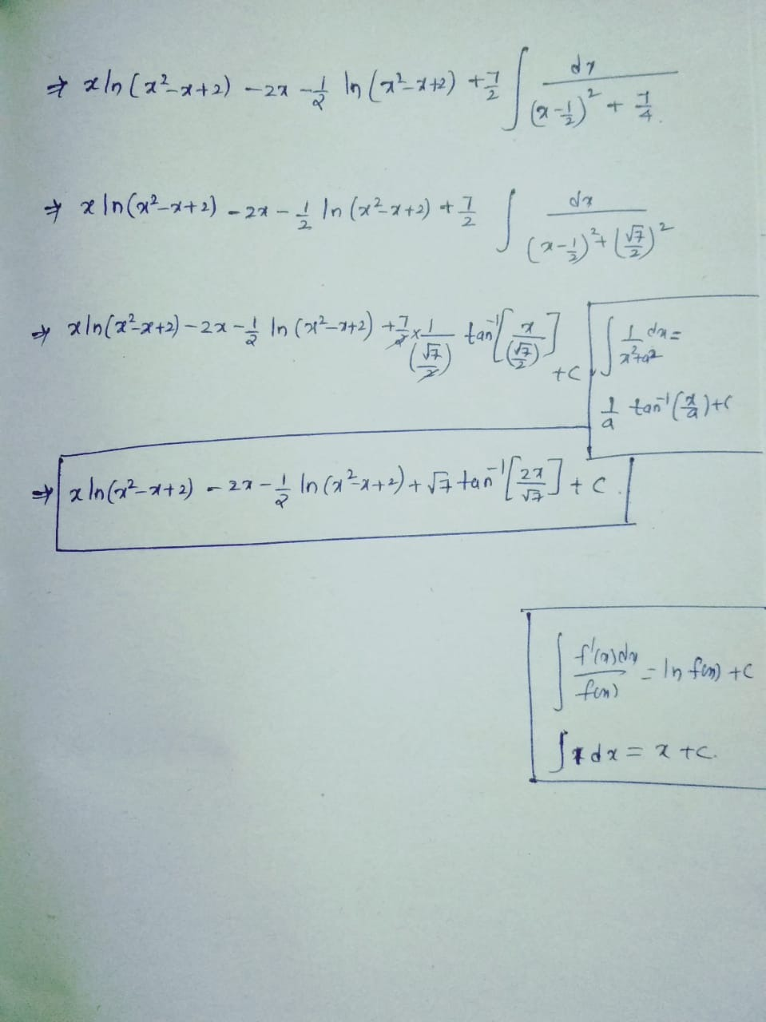

Question 3
$\int_{\frac{π}{4}}^{\frac{π}{3}}{\frac{ln(tanx)}{sinxcosx}}dx$
=$\int_{\frac{π}{4}}^{\frac{π}{3}}{\ln\left(tanx\right)∙\frac{1}{sinxcosx}dx}$
$let u=ln⁡(tanx)$
$du=\frac{1}{tanx}∙\frac{1}{\cos^{2}x}dx=\frac{1}{\frac{sinx}{cosx}}∙\frac{1}{\cos^{2}x}$dx
$=\frac{cosx}{sinx}∙\frac{1}{\cos^{2}x}$dx=$\frac{1}{sinxcosx}dx$
Therefore , $\int_{\frac{π}{4}}^{\frac{π}{3}}{\frac{ln(tanx)}{sinxcosx}}dx=\int_{\frac{π}{4}}^{\frac{π}{3}}{udu=\frac{u^{2}}{2}}$
=$\frac{{\left(ln⁡(tanx)\right)}^{2}}{2}+c$
Ans=$\frac{\ln^{2}(3)}{8}$

4. Evaluating the integral $\int{x\sin^{3}x dx}$
Apply integration by parts : x=u , v=$\sin^{3}x$
$=x\left(-\cos{x}+\frac{1}{3}\cos^{3}x\right)-\int{-cosx+\frac{1}{3}}\cos^{3}xdx$
$=\int{-cosx+\frac{1}{3}}\cos^{3}xdx=-\frac{2}{3}sinx-\frac{1}{9}\sin^{3}x,$
$=x\left(-cosx+\frac{1}{3}\cos^{3}x\right)-\left(-\frac{2}{3}sinx-\frac{1}{9}\sin^{3}x\right)$
=$-xcosx$+$\frac{1}{3}x\cos^{3}x+\frac{2}{3}sinx+\frac{1}{9}\sin^{3}x$
=$-xcosx+\frac{1}{3}x\cos^{3}x+\frac{2}{3}sinx+\frac{1}{9}\sin^{3}x+c$
5. Evaluating using Comparison theorem
$\int_{0}^{∞}{\frac{arctanx}{2+e^{x}}}$
Using the comparison theorem:
Since on the interval $[1,∞)$, the function $actan x$ takes the values between $0 and \frac{π}{2}$ . Also, the numerator of the integral arctan x is bounded by $2+e^{x}$
The dominator tends to behave like $e^{x}$ for the larger values of $x$ . Hence, the integral should have some behaviour of divergence or convergence as $\int_{1}^{∞}{\frac{1}{e^{x}}} dx$=$\int_{1}^{∞}{e^{-x}}$ which is convergent on the interval $[1,∞)$, we have $\frac{arctanx}{2+e^{x}}≤\frac{\frac{π}{2}}{2+e^{x}}$
Since $2+e^{x}>e^{x}>0$, we have $\frac{1}{2+e^{x}}<\frac{1}{e^{x}}$ and thus $\frac{arctanx}{2+e^{x}}≤\frac{\frac{π}{2}}{2+e^{x}}<\frac{\frac{π}{2}}{e^{x}}$
Since $\int_{1}^{∞}{\frac{\frac{π}{2} }{e^{x}}} dx is convergent so \int_{1}^{∞}{\frac{arctanx }{2+e^{x}}}$

